**Materials**

*Chosen Materials for Construction*

For components of our extruder that were made custom by the team, we chose materials that balanced minimizing cost with ensuring satisfactory performance.

We machined our barrel out of 1144 carbon steel. We chose this steel because it is relatively soft, with a hardness of 22 on the Rockwell C scale. Since we machined the part ourselves, we wanted a softer steel so it would be easier to machine. At one point, we had a concern about the barrel being softer than our screw, which is made of 17-4 PH Stainless Steel Con. H900. This type of steel has a hardness of 40 on the Rockwell C scale. Our concern was that if the screw were to hit any part of the barrel, it would leave scratches on the inside of the barrel, or potentially even rupture it. To mitigate this concern, we added a bearing to the end of the screw to ensure complete stability on both ends, preventing any collisions between the screw and barrel.

We also machined a flange to connect the barrel to the feed section of our extruder, which is where our hopper is used to funnel in PET flakes. We made the flange and spacer plate out of 12L14 carbon steel, which is a free machining steel alloy, meaning it is easy to machine.

We ordered custom sheet metal from SendCutSend for the housing surrounding our extruder setup, which is present to ensure safety. We chose to make the housing out of aluminum, because aluminum is lightweight, cost-effective, and sufficiently strong for our purposes. The other material option we considered was stainless steel. Although stainless steel is stronger and more rigid than aluminum, we chose aluminum because it is cheaper than stainless steel, and our housing design does not require the added strength of stainless steel. Our housing only needs to support the weight of a few PID controllers and a VFD on top, so we decided aluminum was a perfectly acceptable strength. In order to bolster the strength of our aluminum housing, we also created a frame out of t-slot aluminum extrusions, allowing us not only to add reinforcement to each face of the housing, but also to easily assemble the housing by simply fastening each sheet metal face to the frame.

The other custom parts in our extruder included shrouds for the fans, to direct streams of air to the exact parts of the barrel where they are needed, a hopper to funnel PET flakes into our feed section, and a mount for the power outlet on the side of our housing. We 3D printed these parts in the Digital Fabrication Lab out of ABS. We chose to print these components out of ABS over PLA mainly due to the heat resistant properties of ABS. Since our extruder heats up the barrel to high temperatures, we wanted anything remotely near the barrel to be made out of heat resistant polymers.

*Material Used by Device*

The most important material pertaining to this project is PET, which is the polymer used to create most plastic bottles, and is therefore the polymer we aimed to recycle using our extruder. When creating filament out of PET, our goal was to create a product that had sufficient material properties to be used for a wide variety of 3D printing applications.

Mechanical properties of a polymer can be critical to the results of 3D printing when the resulting print needs to be strong or durable. Unfortunately, thermal degradation is a factor that needs to be taken into account when using recycled polymers, such as PET. Thermal degradation is the altering of mechanical properties due to small molecular changes to the polymer that occur at high temperatures. In the case of PET, thermal degradation causes lower viscosity, lower melting point, and lower strength. The mechanism of thermal degradation in PET involves transesterification, the breaking of ester bonds and the formation of new bonds.

Our team took the thermal degradation of recycled PET into account in our NEXTRUCAD simulations. Instead of using widely available viscosity data for virgin PET, we searched literature to find viscosity data for recycled PET. Table 1 below shows the viscosity data used in our NEXTRUCAD simulations.

Table 1. Viscosity data for recycled PET from literature.

| T = 270 C | | T = 280 C | | T = 290 C | |
| --- | --- | --- | --- | --- | --- |
| Shear Rate (1/s) | Viscosity (Pa s) | Shear Rate (1/s) | Viscosity (Pa s) | Shear Rate (1/s) | Viscosity (Pa s) |
| 100 | 210 | 100 | 150 | 100 | 150 |
| 200 | 200 | 200 | 140 | 200 | 110 |
| 395 | 185 | 395 | 130 | 395 | 92 |
| 760 | 160 | 760 | 110 | 760 | 82 |
| 1600 | 130 | 1600 | 90 | 1600 | 73 |
| 3200 | 93 | 3000 | 70 | 3000 | 61 |
| 6700 | 63 | 6000 | 55 | 5700 | 50 |
| 15000 | 38 | 13000 | 39 | 11000 | 40 |

Another way we investigated the material properties of our recycled PET was by creating a DSC curve. A DSC curve can be used to determine melting point, crystallization temperature, and glass transition temperature. For our purposes, we were only concerned with finding the melting point, since we need all of the PET in our extruder to be melted to avoid clogging the barrel. Figure 1 below shows the DSC curve we obtained from a sample of one of the plastic bottles we used to make regrind. The dip at 250 °C signifies the melting point of the sample which matches the melting point found in literature.

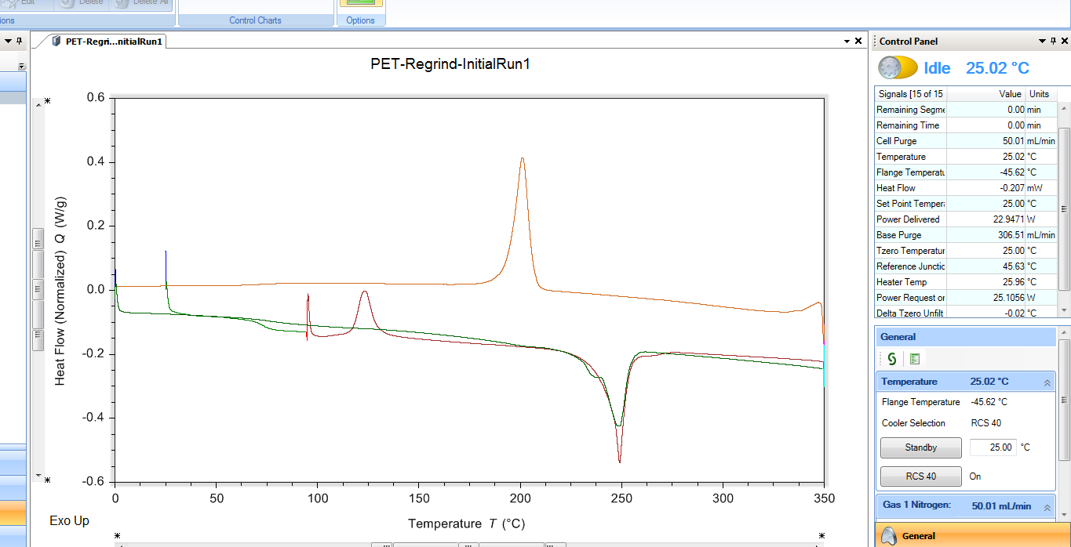

**Figure 1.** DSC Curve from PET regrind

**Equipment Sizing**

The specifications of some parts were critical to the extruder running properly. The motor needed to have sufficient horsepower, the heaters and thermocouples needed to be able to achieve and measure a sufficiently high temperature, and the barrel needed to be thick enough to safely withstand the internal pressure.

From NEXTRUCAD, we determined the required torque of our motor to be 0.26 hp. We chose a slightly oversized motor, with ⅓ hp.

From our DSC curve, we determined the melting point of our recycled PET to be 250 °C. Therefore, we chose heaters that are able to easily achieve that temperature, and thermocouples that can easily measure up to and above that temperature.

The max pressure value was used to determine the required thickness, using Barlow’s Law, where

$P = \frac{2σ_{Θ}s}{D}$

P is the internal pressure, $σ_{Θ}$ is the allowable stress of the material, s is the wall thickness, and D is the outer diameter of the barrel. We chose a barrel thickness of 0.479 in and then used Barlow’s Law to ensure that this selection would produce an allowable stress well below the yield strength of our barrel material. With the barrel thickness of 0.479, a maximum pressure converted to 865 psi, and an outer diameter of 1.109 in, the allowable stress is 1001 psi. The barrel is made from 12L14 steel, which has a yield strength of 60,000 psi. These results signify that our safety factor is around 60, which is exceptionally high.

**Mechanical Assembly**

Table 2 below shows a bill of materials for all mechanical parts that we ordered from commercial vendors. The overall cost was $3,075.92.

**Table 2**. Bill of Mechanical Materials.

| Mechanical |  |  |  |  |
| --- | --- | --- | --- | --- |
| EX6 and MDPE10 extruder screws | 11Feb23 | $869.00 | 1 | $869.00 |
| EX6 EXTRUDER NOZZLES - STYLE X | 11Feb23 | $72.37 | 1 | $72.37 |
| IronHorse MTR series standard efficiency AC induction motor, general purpose and inverter rated, 1/2hp, 3-phase, 230/460 VAC, 1800rpm, TEFC, 56C frame, rolled steel, rigid base/C-face mount. | 20Mar23 | $309.00 | 1 | $309.00 |
| IronHorse medium-duty worm gearbox, 10:1 ratio, 56C-Face input, hollow, 0.625in diameter output shaft, nominal 0.5hp at 1.0 SF, 150 lb-in mechanical output torque, 30mm center distance, cast aluminum housing, top and bottom mount. | 20Mar23 | $139.00 | 1 | $139.00 |
| IronHorse gearbox single output shaft, 0.625in. For use with aluminum WGA-30M series gearboxes. (3) keys, (1) spacer and (1) retaining ring included. | 22Mar23 | $16.50 | 1 | $16.50 |
| Clamping Precision Flexible Shaft Coupling | 8Apr23 | $153.12 | 1 | $153.12 |
| High-Temperature Heater for Pipes and Tubes, 12" Long with Wire Leads (3641K22) | 22Mar23 | $27.49 | 1 | $27.49 |
| High-Temperature Heater for Pipes and Tubes, 6" Long with Wire Leads (3641K21) | 22Mar23 | $27.17 | 2 | $54.34 |
| K Type Thermocouple M8 thread | 22Mar23 | $6.76 | 5 | $33.80 |
| Fiberglass Insulation Sheets (9356K12) | 22Mar23 | $35.20 | 1 | $35.20 |
| 60" High-Temperature Heater for Pipes and Tubes | 8Apr23 | $83.67 | 2 | $167.34 |
| 96" High-Temperature Heater for Pipes and Tubes | 8Apr23 | $113.90 | 1 | $113.90 |
| Round Stock Material for barrel | 27Mar23 | $101.12 | 1 | $101.12 |
| Square Stock Material for feed section | 27Mar23 | $180 | 1 | $180 |
| 1-1/8-7 Die for threads | 27Mar23 | $135.79 | 1 | $135.79 |
| Wrench for round die | 27Mar23 | $91.09 | 1 | $91.09 |
| 1-1/8-7 Tap | 27Mar23 | $126.68 | 1 | $126.68 |
| 7/8-14 Tap | 27Mar23 | $63.98 | 1 | $63.98 |
| Large Tap handle | 27Mar23 | $124.74 | 1 | $124.74 |
| Lathe Turning tool set | 27Mar23 | $157.84 | 1 | $157.84 |
| 41/64” Extended Length Drill bit | 27Mar23 | $103.62 | 1 | $103.62 |
|  |  |  |  | $3,075.92 |

We used Fusion 360 to create a 3D rendering of our extruder before starting with physical assembly. Please see our [CAD page] for an interactive model of our full extruder assembly and links to pictures and individual CAD models of each mechanical and electrical part we used in assembly.

**Electrical**

Table 3 below shows a bill of materials for all electrical components of our extruder. The overall cost was $861.22.

**Table 3.** Bill of Electrical Materials.

| Electrical |  |  |  |  |
| --- | --- | --- | --- | --- |
| Variable Frequency Drive | 20Mar23 | $118.84 | 1 | $118.84 |
| RioRand 7-70V PWM DC Motor Speed Controller Switch 30A | 22Mar23 | $15.99 | 3 | $47.97 |
| Emergency Stop Button | 22Mar23 | $12.99 | 1 | $12.99 |
| Power Supply | 22Mar23 | $12.99 | 3 | $25.98 |
| AC Power Connector | 8Apr23 | $9.49 | 1 | $8.99 |
| Power Supply | 8Apr23 | $12.99 | 1 | $12.99 |
| IEC Connector (1333N14) | 8Apr23 | $17.33 | 1 | $17.33 |
| 8 position dual row terminal strip block | 8Apr23 | $14.89 | 1 | $14.89 |
| PID Temp Controller | 22Mar23 | $197.45 | 3 | $592.35 |
| Electrical Crimp Terminal for 16-14AWG Cable | 8Apr23 | $8.89 | 1 | $8.89 |
|  |  |  |  | $861.22 |

To complete our extruder, our team wired a variety of parts. The diagram shown below in figure X illustrates the flow of our wiring and all necessary components. The extruder receives current from a wall outlet, and splits it into three multiple streams using terminal strips. There is a terminal strip for live, a strip for neutral, and a strip for ground. Some current goes to the VFD, which controls the motor. Some current goes to cooling fans controlled by PWM knobs, which accept 12 V so the current must pass through converters first. The rest of the current goes to PID controllers, where the current temperature is measured by thermocouples and the desired temperature is controlled with heaters. After initially wiring all PID controllers and all fans separately, we decided to daisy chain them because it made cable management easier, reduced the risk of any wire touching the barrel insulation, and allowed for easier removal of the top housing panel.



**Figure X.** Wiring Logic Flowchart